PSI USING StaMPS
For Sentinel-1A/B,

How to prepare Sentinel-1 images stack for PSI/SBAS in SNAP
Note: (8) images is a very small stack for PS identification, usually 20+ scenes are used/recommended.

- For S1, apply TOPS split and then apply precise orbit.
- Add all products to the Backgeocoding.
- Create Stack of Backgeocoded images (master_Stack).
- Create a stack of Interferograms (Follow the step one of Prepare for STACK AVERAGING) on the resulting stack. {STEP 1: master (SAME MASTER)+ (Different Slaves)first slave -> TOPS Corregistration, if necessary Deburst (and possibly subset), Interferogram, topographic phase removal, } master_Stack_ifg_dinsar .
- Deburst both the Backgeocoded stack (master_Stack_Deb), and the Interferogram stack (master_Stack_Deb_ifg_dinsar .).
- Add an elevation band to the Interferogram stack (by right-click > add elevation raster.).
- Add the Debursted stack and Debursted Interferogram stack to the stamps export.

Below is a description of for a case when a study area is within one IW swath OR within one burst.
NOTE: 12-13 images are OK for each Stack. If more images in the Stack - it is better to split it into several Stacks each having the same master. Master can be chosen by Radar-Interferometric-InSAR Stack Overview.
NOTE: StaMPS works with wrapped Interferograms as input. Unwrapping is done in PS at the last stage. So Goldstein Phase filtering or Multilooking before export to StaMPS should not be done.
Note: Multilooking could be done just to examine the Interferograms - this sometimes helps to determine a signal.) -multilooking reduces the chance for getting suitable persistent scatterers: As the pixel size increases, the chance that there is one dominant scatterer which exceeds all others in this pixel is reduced. So mutilooking is not prohibited but not necessarily contributing to good results. -Now multilooking is not necessary, StaMPS will resample images throughout the process before phase unwrapping.
Andy Hooper StaMPS PS exercise: http://seom.esa.int/landtraining2015/files/Day_4/D4P2a_LTC2015_Hooper.pdf4
Prepare data for StaMPS: Radar-Interferometric-PSI/SBAS-StaMPS EXPORT
Exported to StaMPS the two files:
- master_Stack_Deb_ifg_dinsar AND master_Stack_Deb
- After the Exportation to StaMPS four directories are gotten (/diff0, /geo,/dem,/rslc)
- Replace the former directories to the directory name (INSAR_master_data)
NOTE: In case of several Stacks export each Stack and then copy results to the directories directories /diff0, /geo,/dem,/rslc.
NOTE: It is possible to only copy /diff0 and /rslc, and doesn’t need to copy /geo and /dem
- To have PS geocoded add (Lon & Lat) bands to the result of 5 (master_Stack_Deb)
NOTE: (Right click -band maths-edit expressions-constants-lon (then lat) (UNCHECK "virtual" to save expression).
- Export results to (ENVI or GAMMA format), Save result, for example, to /geo directory. Rename files with lon and lat to master_data.lon and master_data.lat. These are binary files with latitudes and longitudes.
NOTE: For all pixels of the master crop. (One file contains values of lat for all pixels and the other - of lon) All the other files (results of export of the other bands) can be deleted. The files master_data.lon and master_data.lat should be placed into /geo directory.
NOTE: Use master_data.lon and master_data.lat could have PS geocoded, TC is also workable.
- Place the new scripts mt_prep_gamma to the /bin directory of StaMPS.
- Place ps_load_initial_gamma.m to the StaMPS matlab directory.
- Run mt_prep_gamma from the INSAR_masterdata directory.
NOTE: Should use mt_prep_gamma_snap (changed) provided by FeiLiu, It is possible to rename the file name or not, the use of this script has also been discussed in this topic? If the script ps_load_initial_gamma_snap.m provided by Katherine, workable then everything is OK, else: use the file ps_load_initial_gamma_snap (changed).m provided by FeiLiu, In any case, to rename the file to ps_load_initial_gamma.m and replace the original one.
- Run matlab and launch StaMPS.

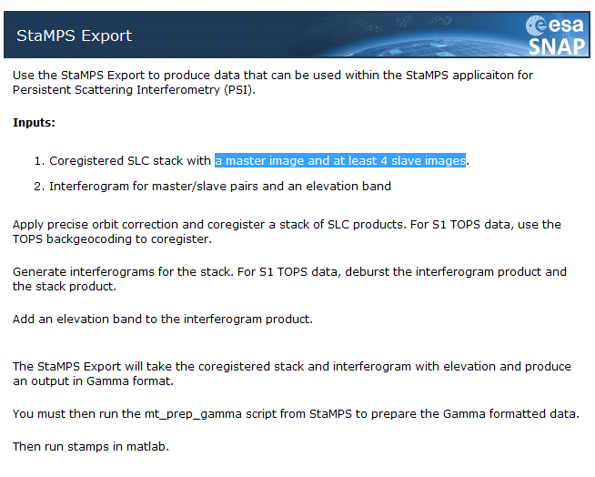
There is a tutorial on command line processing on the tutorials page http://step.esa.int/main/doc/tutorials/

How did you get StaMP installed under cygwin?
Download the rar-file (https://homepages.see.leeds.ac.uk/~earahoo/stamps/)
- Unpack it to C:\Temp\StaMPS
- cd /cygdrive/c/temp/StaMPS
- make
- make install
This compiles the files which can be executed by the cygwin shell. You can run them with csh.
Some are also converted to exe-formats.
Same applies for the other packages.
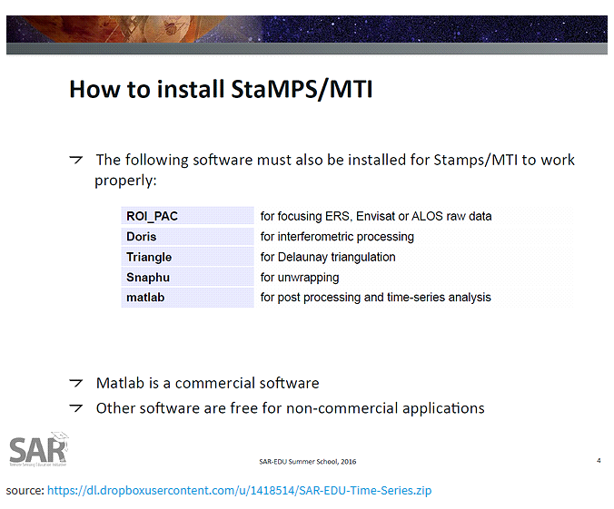

Prepare for STACK AVERGING
STEP 1: master+first slave -> TOPS Corregistration, if necessary Deburst (and possibly subset), interferogram, topographic phase removal,
STEP 2: master+second slave -> coregistration, if necessary deburst (and possibly subset), interferogram, topographic phase removal.
STEP 3: master+third slave -> coregistration, if necessary deburst (and possibly subset), interferogram, topographic phase removal.
STEP 4: master+fourth slave -> coregistration, if necessary deburst (and possibly subset), interferogram, topographic phase removal.
STEP 5: Create a stack with results of step1,step2, step3, step4. STEP……
STEP 6 Create stacking averaging
STEP 7 SNAPHU EXPORT
STEP 8 UNWRAPPING
STEP 9 SNAPHU IMPORT
STEP 10 PHASE TO DISPLACEMENT

