PSI USING StaMPS
For Sentinel-1A/B,

How to prepare Sentinel-1 images stack for PSI/SBAS in SNAP
Note: (8) images is a very small stack for PS identification, usually 20+ scenes are used/recommended.
Bayzidul:
-Satellite orbital path must be the same for both satellites
-Orbit direction must be the same (both ascending or descending orbits)
- No, you can't generate an interferogram between ascending and descending acquisitions.

- For S1, apply TOPS split and then apply precise orbit.
- Add all products to the Backgeocoding.
- Create Stack of Backgeocoded images (master_Stack).
- Create a stack of Interferograms (Follow the step one of Prepare for STACK AVERAGING) on the resulting stack. {STEP 1: master (SAME MASTER)+ (Different Slaves)first slave -> TOPS Corregistration, if necessary Deburst (and possibly subset), Interferogram, topographic phase removal, } master_Stack_ifg_dinsar .
- Deburst both the Backgeocoded stack (master_Stack_Deb), and the Interferogram stack (master_Stack_Deb_ifg_dinsar .).
- Add an elevation band to the Interferogram stack (by right-click > add elevation raster.).
- Add the Debursted stack and Debursted Interferogram stack to the stamps export.

Bayzidul:
In the StaMPS export add Debrusted stack first then Debrusted Interferogram

Below is a description of for a case when a study area is within one IW swath OR within one burst.
NOTE: 12-13 images are OK for each Stack. If more images in the Stack - it is better to split it into several Stacks each having the same master. Master can be chosen by Radar-Interferometric-InSAR Stack Overview.
NOTE: StaMPS works with wrapped Interferograms as input. Unwrapping is done in PS at the last stage. So Goldstein Phase filtering or Multilooking before export to StaMPS should not be done.
Note: Multilooking could be done just to examine the Interferograms - this sometimes helps to determine a signal.) -multilooking reduces the chance for getting suitable persistent scatterers: As the pixel size increases, the chance that there is one dominant scatterer which exceeds all others in this pixel is reduced. So mutilooking is not prohibited but not necessarily contributing to good results. -Now multilooking is not necessary, StaMPS will resample images throughout the process before phase unwrapping.
Andy Hooper StaMPS PS exercise: http://seom.esa.int/landtraining2015/files/Day_4/D4P2a_LTC2015_Hooper.pdf4
Prepare data for StaMPS: Radar-Interferometric-PSI/SBAS-StaMPS EXPORT
Exported to StaMPS the two files:
- master_Stack_Deb_ifg_dinsar AND master_Stack_Deb
- After the Exportation to StaMPS four directories are gotten (/diff0, /geo,/dem,/rslc)
- Replace the former directories to the directory name (INSAR_master_data)
NOTE: In case of several Stacks export each Stack and then copy results to the directories /diff0, /geo,/dem,/rslc.
Bayzidul:
When we have several stack, then we can easily copy from Stack-2’s /diff0 and /rslc files in Stack-1/diff0 and /rslc folder but /geo and /dem generates same file name, so should we merge while copying or how is it ??
- To have PS geocoded add (Lon & Lat) bands to the result of 5 (master_Stack_Deb)
NOTE: (Right click -band maths-edit expressions-constants-lon (then lat) (UNCHECK "virtual" to save expression).
Bayzidul:
It is also mentioned that, to have PS Geocoded you can do also Terrain Correction or Update Geo reference [Which one is the correct solution ??]

- Export results to (ENVI or GAMMA format), Save result, for example, to /geo directory. Rename files with lon and lat to master_data.lon and master_data.lat. These are binary files with latitudes and longitudes.
NOTE: For all pixels of the master crop. (One file contains values of lat for all pixels and the other - of lon) All the other files (results of export of the other bands) can be deleted. The files master_data.lon and master_data.lat should be placed into /geo directory.
Bayzidul:
When you export as Gamma format and save as master_data.lon and master_data.lat then what is the file format, is it .lon and .lat or it is .rslc. That means .lon and .lat is a part of the name or ???
Also, we have several recommendations and what should be the exact name master_data.lon OR 20150303.lon.rslc and same for lat.??

- Place the new scripts mt_prep_gamma to the /bin directory of StaMPS.
- Place ps_load_initial_gamma.m to the StaMPS matlab directory.
- Run mt_prep_gamma from the INSAR_master_data directory.
Bayzidul:
Which file is correct???
According to Katherine we have to use mt_prep_gamma_snap and ps_load_initial_gamma_snap.m and according to Fei mt_prep_gamma_snap_(changed) and ps_load_initial_gamma_snap_(changed).m
The two file post by Katherine, "mt_prep_gamma_snap" is different from "mt_prep_gamma", and I use "mt_prep_gamma_snap", it works for me (and I haven't use "mt_prep_gamma"). But the file "ps_load_initial_gamma_snap" is same as "ps_load_initial_gamma" expect for a ';', which has some problems in my work, so I have modified it.
Hope this helps
Fei
What is the correct process to run codes ??
mt_prep_gamma 20150806 /data2/.../Export_to_stamps/ 0.4 2 2 50 200
where:
mt_prep_gamma [your master] [full path to your working directory] [Amplitude disp.] [Number of patches in range] [Number of patches in azimuth] [overlapping pixels between patches in range] [overlapping pixels between patches in azimuth]
Or
cd /data2/
sudo StaMPS-bin-dir/ mt_prep_gamma 20150806 /data2/.../Export_to_stamps/ 0.4 2 2 50 200

- Run matlab and launch StaMPS.
Bayzidul:
Run matlab from the same working directory from the command line. Then should we run stamps(1,1) or it is the same.

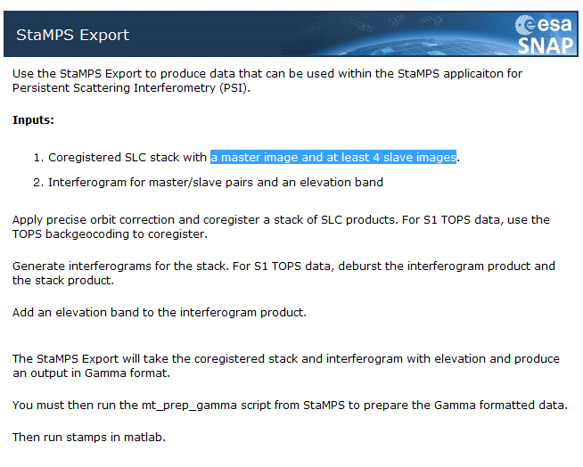
There is a tutorial on command line processing on the tutorials page http://step.esa.int/main/doc/tutorials/

How did you get StaMP installed under cygwin?
Download the rar-file (https://homepages.see.leeds.ac.uk/~earahoo/stamps/)
- Unpack it to C:\Temp\StaMPS
- cd /cygdrive/c/temp/StaMPS
- make
- make install
This compiles the files which can be executed by the cygwin shell. You can run them with csh.
Some are also converted to exe-formats.
Same applies for the other packages.
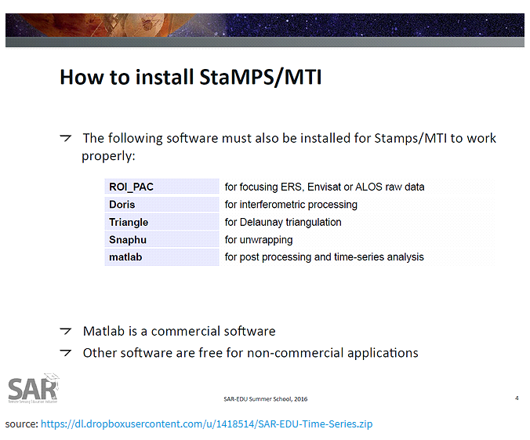
Bayzidul:
Can anyone expalin the process to install StaMPS in Linux??
In my case in Linux, I put StamPS_v3.3b1 at /usr/local and form there I run make and make install.
I added the path “/usr/local/ StamPS_v3.3b1/bin” in StaMPS_CONIF.bash file, .bashrc file and also in .profile (Is it the correct way to install in Linux??)

export PATH=$PATH:/usr/local/ StamPS_v3.3b1/bin
export PATH=$PATH:/usr/local/ StamPS_v3.3b1/matlab
source PATH=$PATH:/usr/local/ StamPS_v3.3b1/StamPS_CONFIG.bash

How important it is to install all other software mentioned in the StaMPS_CONFIG file see below. ??
The ROI_PAC is currently not available, can any of you please send me (bislam@psg.tu-darmstadt.de). ??

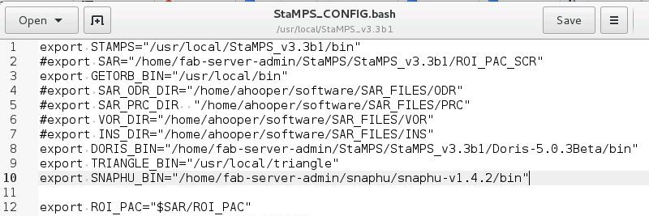
Prepare for STACK AVERGING
STEP 1: master+first slave -> TOPS Corregistration, if necessary Deburst (and possibly subset), interferogram, topographic phase removal,
STEP 2: master+second slave -> coregistration, if necessary deburst (and possibly subset), interferogram, topographic phase removal.
STEP 3: master+third slave -> coregistration, if necessary deburst (and possibly subset), interferogram, topographic phase removal.
STEP 4: master+fourth slave -> coregistration, if necessary deburst (and possibly subset), interferogram, topographic phase removal.
STEP 5: Create a stack with results of step1,step2, step3, step4. STEP……
STEP 6 Create stacking averaging
STEP 7 SNAPHU EXPORT
STEP 8 UNWRAPPING
STEP 9 SNAPHU IMPORT
STEP 10 PHASE TO DISPLACEMENT

