Dear NASA,
Your attention and very precious time allocated to help response again would be very appreciated.

Thank you very much regarding coordinate.

At this time, we cannot generate RGB for file
S1B_IW_GRDH_1SDV_20180927T112000_20180927T112025_012900_017D2D_1BFD.zip
Got the attached error message.

Thank you very much in advance with very most regards,
Busaba

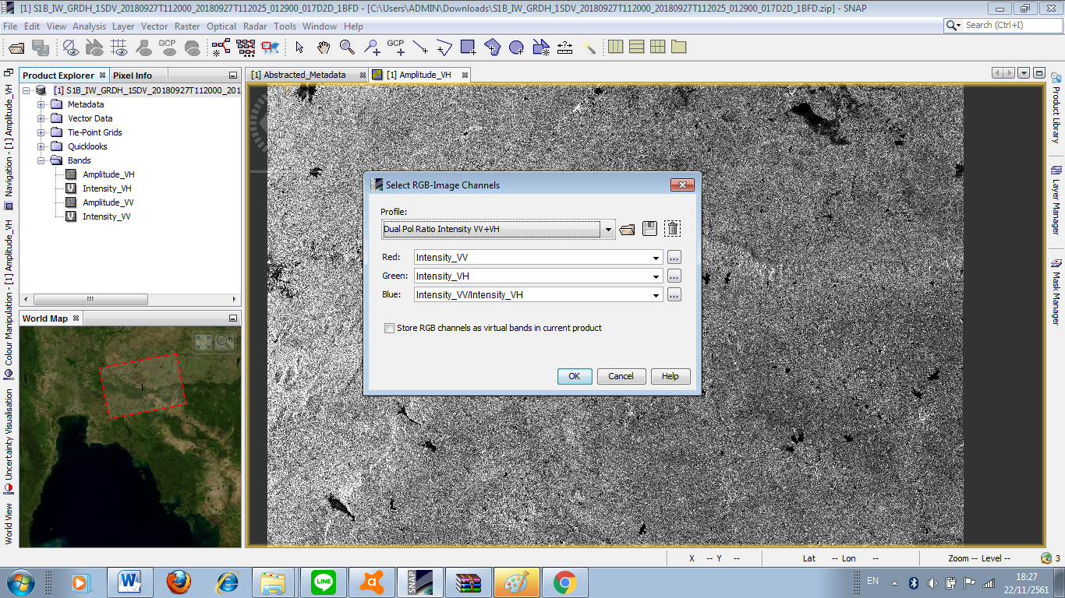
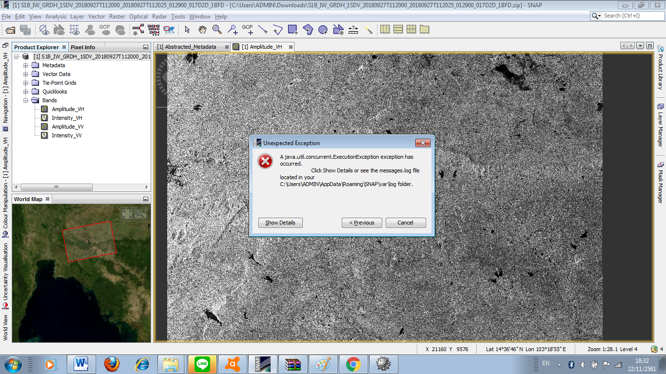
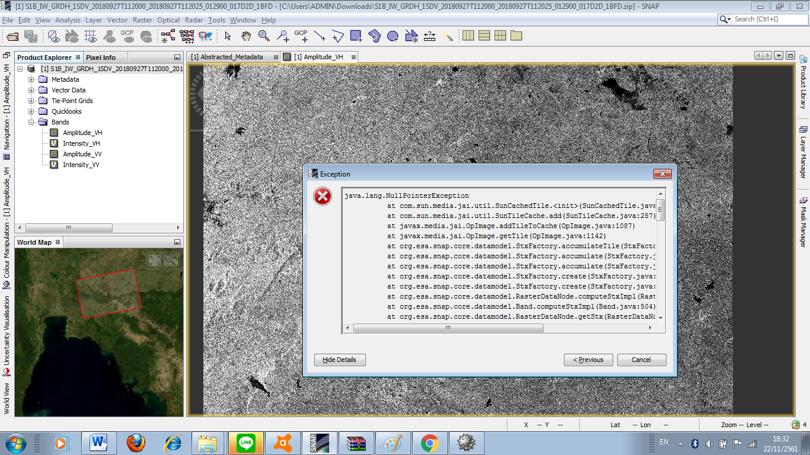
java.lang.NullPointerException
at com.sun.media.jai.util.SunCachedTile.<init>(SunCachedTile.java:80)
at com.sun.media.jai.util.SunTileCache.add(SunTileCache.java:257)
at javax.media.jai.OpImage.addTileToCache(OpImage.java:1087)
at javax.media.jai.OpImage.getTile(OpImage.java:1142)
at org.esa.snap.core.datamodel.StxFactory.accumulateTile(StxFactory.java:339)
at org.esa.snap.core.datamodel.StxFactory.accumulate(StxFactory.java:323)
at org.esa.snap.core.datamodel.StxFactory.accumulate(StxFactory.java:296)
at org.esa.snap.core.datamodel.StxFactory.create(StxFactory.java:200)
at org.esa.snap.core.datamodel.StxFactory.create(StxFactory.java:274)
at org.esa.snap.core.datamodel.RasterDataNode.computeStxImpl(RasterDataNode.java:2453)
at org.esa.snap.core.datamodel.Band.computeStxImpl(Band.java:504)
at org.esa.snap.core.datamodel.RasterDataNode.getStx(RasterDataNode.java:2420)
at org.esa.snap.core.datamodel.RasterDataNode.createDefaultImageInfo(RasterDataNode.java:1827)
at org.esa.snap.core.datamodel.Band.createDefaultImageInfo(Band.java:483)
at org.esa.snap.core.datamodel.RasterDataNode.getImageInfo(RasterDataNode.java:1809)
at org.esa.snap.core.datamodel.RasterDataNode.getImageInfo(RasterDataNode.java:1792)
at org.esa.snap.core.image.ImageManager.prepareImageInfos(ImageManager.java:834)
at org.esa.snap.core.image.ColoredBandImageMultiLevelSource.create(ColoredBandImageMultiLevelSource.java:51)
at org.esa.snap.core.image.ColoredBandImageMultiLevelSource.create(ColoredBandImageMultiLevelSource.java:47)
at org.esa.snap.ui.product.ProductSceneImage.<init>(ProductSceneImage.java:103)
at org.esa.snap.rcp.actions.window.OpenRGBImageViewAction.createProductSceneImageRGB(OpenRGBImageViewAction.java:209)
at org.esa.snap.rcp.actions.window.OpenRGBImageViewAction.access$000(OpenRGBImageViewAction.java:74)
at org.esa.snap.rcp.actions.window.OpenRGBImageViewAction$1.doInBackground(OpenRGBImageViewAction.java:160)
at org.esa.snap.rcp.actions.window.OpenRGBImageViewAction$1.doInBackground(OpenRGBImageViewAction.java:156)
at com.bc.ceres.swing.progress.ProgressMonitorSwingWorker.doInBackground(ProgressMonitorSwingWorker.java:55)
at javax.swing.SwingWorker$1.call(Unknown Source)
at java.util.concurrent.FutureTask.run(Unknown Source)
at javax.swing.SwingWorker.run(Unknown Source)
at java.util.concurrent.ThreadPoolExecutor.runWorker(Unknown Source)
at java.util.concurrent.ThreadPoolExecutor$Worker.run(Unknown Source)
at java.lang.Thread.run(Unknown Source)
Caused: java.util.concurrent.ExecutionException
at java.util.concurrent.FutureTask.report(Unknown Source)
at java.util.concurrent.FutureTask.get(Unknown Source)
at javax.swing.SwingWorker.get(Unknown Source)
[catch] at org.esa.snap.rcp.actions.window.OpenRGBImageViewAction$1.done(OpenRGBImageViewAction.java:169)
at javax.swing.SwingWorker$5.run(Unknown Source)
at javax.swing.SwingWorker$DoSubmitAccumulativeRunnable.run(Unknown Source)
at sun.swing.AccumulativeRunnable.run(Unknown Source)
at javax.swing.SwingWorker$DoSubmitAccumulativeRunnable.actionPerformed(Unknown Source)
at javax.swing.Timer.fireActionPerformed(Unknown Source)
at javax.swing.Timer$DoPostEvent.run(Unknown Source)
at java.awt.event.InvocationEvent.dispatch(Unknown Source)
at java.awt.EventQueue.dispatchEventImpl(Unknown Source)
at java.awt.EventQueue.access$500(Unknown Source)
at java.awt.EventQueue$3.run(Unknown Source)
at java.awt.EventQueue$3.run(Unknown Source)
at java.security.AccessController.doPrivileged(Native Method)
at java.security.ProtectionDomain$JavaSecurityAccessImpl.doIntersectionPrivilege(Unknown Source)
at java.awt.EventQueue.dispatchEvent(Unknown Source)
at org.netbeans.core.TimableEventQueue.dispatchEvent(TimableEventQueue.java:159)
at java.awt.EventDispatchThread.pumpOneEventForFilters(Unknown Source)
at java.awt.EventDispatchThread.pumpEventsForFilter(Unknown Source)
at java.awt.EventDispatchThread.pumpEventsForHierarchy(Unknown Source)
at java.awt.EventDispatchThread.pumpEvents(Unknown Source)
at java.awt.EventDispatchThread.pumpEvents(Unknown Source)
at java.awt.EventDispatchThread.run(Unknown Source)

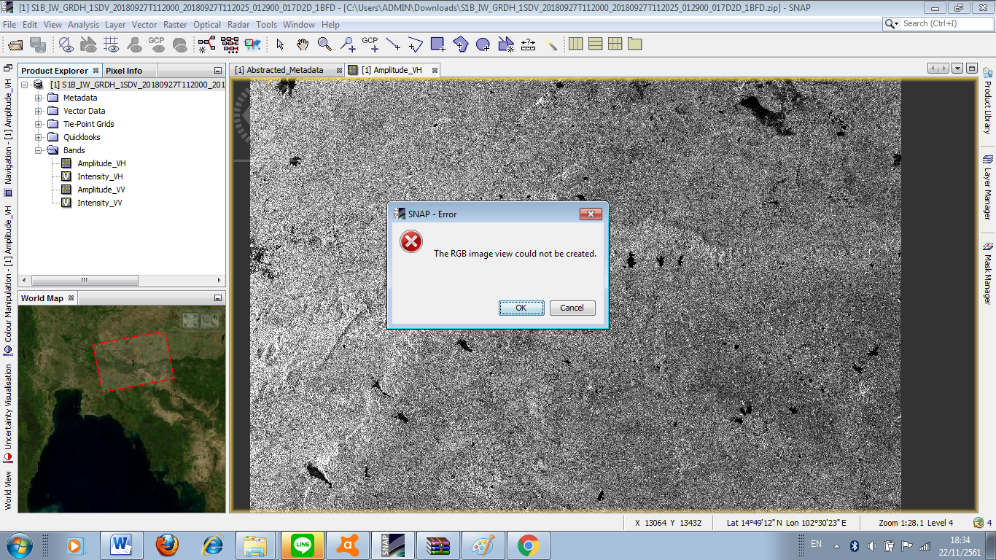

java.lang.NullPointerException
at com.sun.media.jai.util.SunCachedTile.<init>(SunCachedTile.java:80)
at com.sun.media.jai.util.SunTileCache.add(SunTileCache.java:257)
at javax.media.jai.OpImage.addTileToCache(OpImage.java:1087)
at javax.media.jai.OpImage.getTile(OpImage.java:1142)
at org.esa.snap.core.datamodel.StxFactory.accumulateTile(StxFactory.java:339)
at org.esa.snap.core.datamodel.StxFactory.accumulate(StxFactory.java:323)
at org.esa.snap.core.datamodel.StxFactory.accumulate(StxFactory.java:296)
at org.esa.snap.core.datamodel.StxFactory.create(StxFactory.java:200)
at org.esa.snap.core.datamodel.StxFactory.create(StxFactory.java:274)
at org.esa.snap.core.datamodel.RasterDataNode.computeStxImpl(RasterDataNode.java:2453)
at org.esa.snap.core.datamodel.Band.computeStxImpl(Band.java:504)
at org.esa.snap.core.datamodel.RasterDataNode.getStx(RasterDataNode.java:2420)
at org.esa.snap.core.datamodel.RasterDataNode.createDefaultImageInfo(RasterDataNode.java:1827)
at org.esa.snap.core.datamodel.Band.createDefaultImageInfo(Band.java:483)
at org.esa.snap.core.datamodel.RasterDataNode.getImageInfo(RasterDataNode.java:1809)
at org.esa.snap.core.datamodel.RasterDataNode.getImageInfo(RasterDataNode.java:1792)
at org.esa.snap.core.image.ImageManager.prepareImageInfos(ImageManager.java:834)
at org.esa.snap.core.image.ColoredBandImageMultiLevelSource.create(ColoredBandImageMultiLevelSource.java:51)
at org.esa.snap.core.image.ColoredBandImageMultiLevelSource.create(ColoredBandImageMultiLevelSource.java:47)
at org.esa.snap.ui.product.ProductSceneImage.<init>(ProductSceneImage.java:103)
at org.esa.snap.rcp.actions.window.OpenRGBImageViewAction.createProductSceneImageRGB(OpenRGBImageViewAction.java:209)
at org.esa.snap.rcp.actions.window.OpenRGBImageViewAction.access$000(OpenRGBImageViewAction.java:74)
at org.esa.snap.rcp.actions.window.OpenRGBImageViewAction$1.doInBackground(OpenRGBImageViewAction.java:160)
at org.esa.snap.rcp.actions.window.OpenRGBImageViewAction$1.doInBackground(OpenRGBImageViewAction.java:156)
at com.bc.ceres.swing.progress.ProgressMonitorSwingWorker.doInBackground(ProgressMonitorSwingWorker.java:55)
at javax.swing.SwingWorker$1.call(Unknown Source)
at java.util.concurrent.FutureTask.run(Unknown Source)
at javax.swing.SwingWorker.run(Unknown Source)
at java.util.concurrent.ThreadPoolExecutor.runWorker(Unknown Source)
at java.util.concurrent.ThreadPoolExecutor$Worker.run(Unknown Source)
at java.lang.Thread.run(Unknown Source)
Caused: java.util.concurrent.ExecutionException
at java.util.concurrent.FutureTask.report(Unknown Source)
at java.util.concurrent.FutureTask.get(Unknown Source)
at javax.swing.SwingWorker.get(Unknown Source)
[catch] at org.esa.snap.rcp.actions.window.OpenRGBImageViewAction$1.done(OpenRGBImageViewAction.java:169)
at javax.swing.SwingWorker$5.run(Unknown Source)
at javax.swing.SwingWorker$DoSubmitAccumulativeRunnable.run(Unknown Source)
at sun.swing.AccumulativeRunnable.run(Unknown Source)
at javax.swing.SwingWorker$DoSubmitAccumulativeRunnable.actionPerformed(Unknown Source)
at javax.swing.Timer.fireActionPerformed(Unknown Source)
at javax.swing.Timer$DoPostEvent.run(Unknown Source)
at java.awt.event.InvocationEvent.dispatch(Unknown Source)
at java.awt.EventQueue.dispatchEventImpl(Unknown Source)
at java.awt.EventQueue.access$500(Unknown Source)
at java.awt.EventQueue$3.run(Unknown Source)
at java.awt.EventQueue$3.run(Unknown Source)
at java.security.AccessController.doPrivileged(Native Method)
at java.security.ProtectionDomain$JavaSecurityAccessImpl.doIntersectionPrivilege(Unknown Source)
at java.awt.EventQueue.dispatchEvent(Unknown Source)
at org.netbeans.core.TimableEventQueue.dispatchEvent(TimableEventQueue.java:159)
at java.awt.EventDispatchThread.pumpOneEventForFilters(Unknown Source)
at java.awt.EventDispatchThread.pumpEventsForFilter(Unknown Source)
at java.awt.EventDispatchThread.pumpEventsForHierarchy(Unknown Source)
at java.awt.EventDispatchThread.pumpEvents(Unknown Source)
at java.awt.EventDispatchThread.pumpEvents(Unknown Source)
at java.awt.EventDispatchThread.run(Unknown Source)

