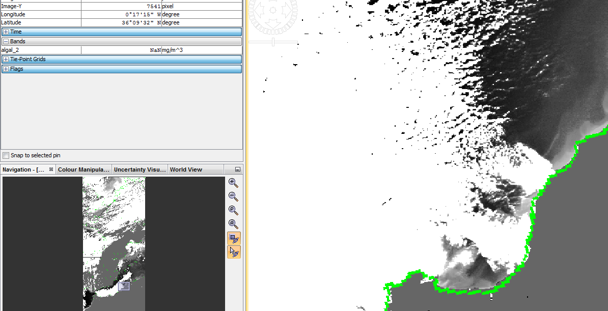

**Original algal_2 band**

**CLOUD**

**algal_2 band after applying the bandmath expression**

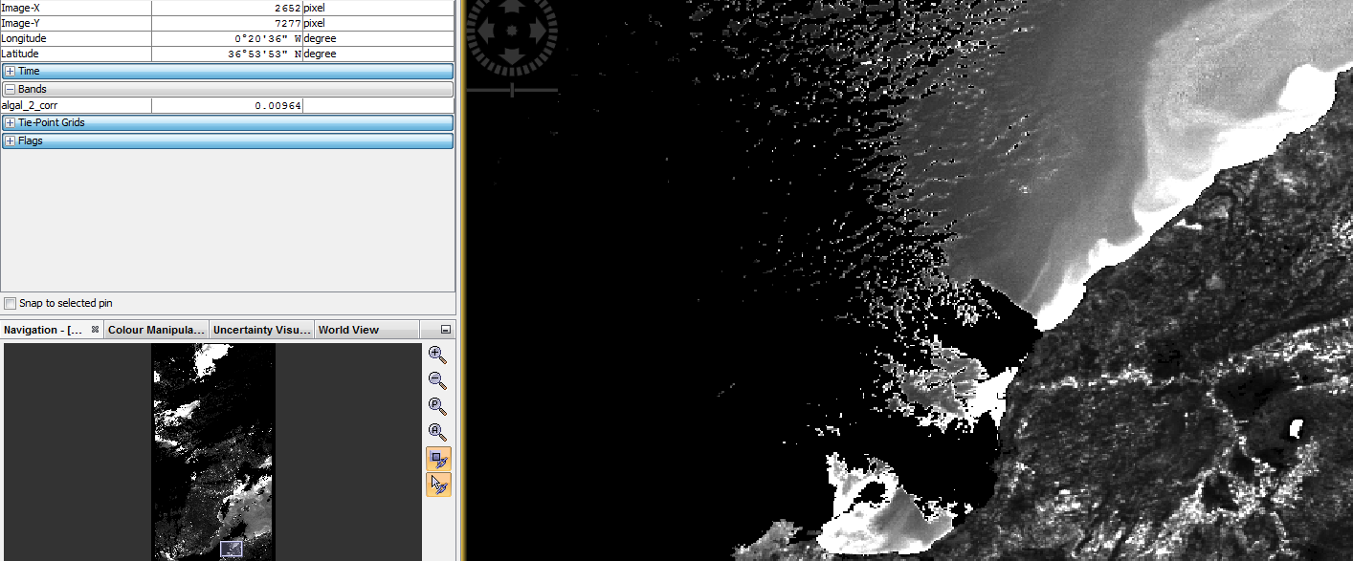

**LAND**

**CLOUD**