Figure 1 i_IW1_VH
（File Name：S1A_IW_SLC__1SDV_20210202T121040_20210202T121108_036411_044618_0661）
Figure 2 q_IW1_VH
（File Name：S1A_IW_SLC__1SDV_20210202T121040_20210202T121108_036411_044618_0661）

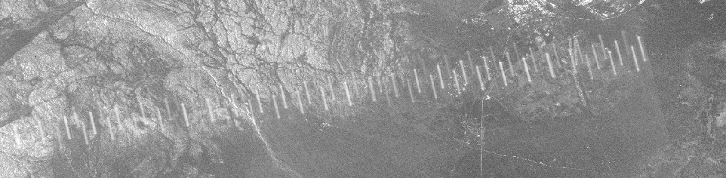
Figure 3 SLC to Geocoding_VH created by Snap
（File Name：S1A_IW_SLC__1SDV_20210202T121040_20210202T121108_036411_044618_0661）
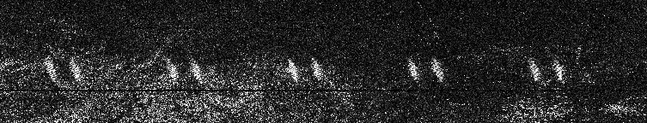
Figure 4 Intensity_IW1_VH
(File Name:
S1A_IW_SLC__1SDV_20181203T121030_20181203T121058_024861_02BCD8_5FD6)

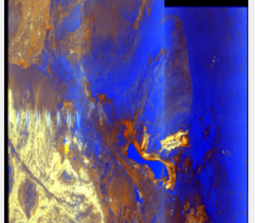
Figure 5 Quicklook
(File Name:
S1A_IW_SLC__1SDV_20181203T121030_20181203T121058_024861_02BCD8_5FD6)

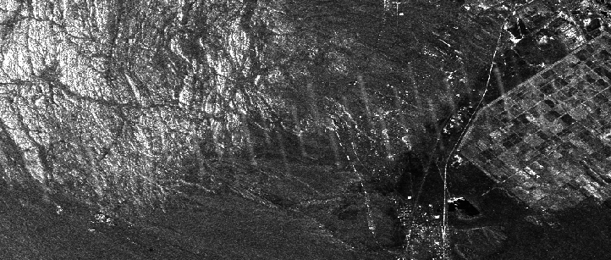
Figure 6 SLC to Geocoding_VV created by Snap
（File Name： S1A_IW_SLC__1SDV_20210509T121042_20210509T121110_037811_047676_AB79）

