**WORKFLOW FOR snap2stamps OPERATION using**

<https://github.com/mdelgadoblasco/snap2stamps> (SNAP2StaMPS v2: Using SNAP as InSAR processor for StaMPS)

<https://forum.step.esa.int/t/snap2stamps-error/16768/266?page=12> -Discussion on Error

**Step-1**

Download the required Sentinel-1 image from ASF Data Search Vertex and store it in Folder “secondaries”

F:\SNAP2StaMPS\secondaries (There are **47 Sentinel-**1 images in my case)

Make sure the other folders exist in F:\SNAP2StaMPS\ location along with secondaries such as

F:\SNAP2StaMPS\bin

F:\SNAP2StaMPS\graphs

F:\SNAP2StaMPS\Manual

**Step-2**

Check whether project_topsar.conf is located in F:\SNAP2StaMPS\project_topsar.conf & Adjust the project_topsar.conf parameters as per the study area requirement.

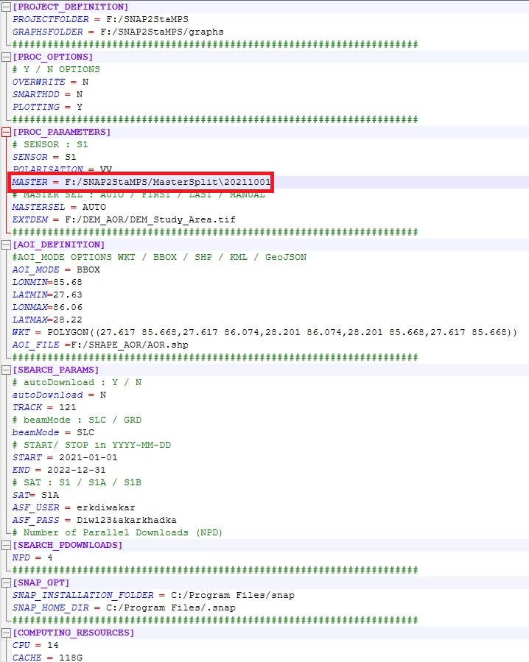

Make sure that the master image (“/.zip”) file is moved **manually** to the folder location after executing **Step-5**.

**Step-3**

Check the python execution file lies below:

F:\SNAP2StaMPS\ auto_run.py

F:\SNAP2StaMPS\topsar_automaster.py

F:\SNAP2StaMPS\topsar_step_0_secondaries_prep.py

F:\SNAP2StaMPS\topsar_step_1_splitting_master_multi_IW.py

F:\SNAP2StaMPS\topsar_step_2_splitting_secondaries.py

F:\SNAP2StaMPS\topsar_step_3_coreg_ifg_topsar_smart.py

F:\SNAP2StaMPS\topsar_step_4_plotting_all.py

F:\SNAP2StaMPS\topsar_step_5_stamps_export_multiIW.py

And Execute

**F:\SNAP2StaMPS>python auto_run.py -F project_topsar.conf**

After that the additional folder are created, check whether the following those folders are created or not:

F:\SNAP2StaMPS\MasterSplit

F:\SNAP2StaMPS\split

F:\SNAP2StaMPS\coreg

F:\SNAP2StaMPS\ifg

Once, it is created proceed to step-4.

**Step-4**

**F:\SNAP2StaMPS>python topsar_step_0_secondaries_prep.py -F F:/SNAP2StaMPS/project_topsar.conf**

The no. of unique folder is created in the name of date of Sentinel-1 data acquit ions, such as F:\SNAP2StaMPS\secondaries\ (YYYY-MM-DD) (There are **47 folders** created in my case)

**Step-5**

**F:\SNAP2StaMPS>python topsar_automaster.py -F** **F:/SNAP2StaMPS/project_topsar.conf -M AUTO**

After executing the above script, the automatic selection of master image is suggested by this code.

Make sure master image lies within in folder **(e.g: 20211001 was master image in my case)**

F:\SNAP2StaMPS\secondaries\20211001\ **S1A_IW_SLC__1SDV_20211001T001138_20211001T001205_039918_04B945_C208.zip**

Now, after knowing that master image is 20211001, **move** the above .zip file in the location set at Step-2.

F:\SNAP2StaMPS\MasterSplit\20211001\ **S1A_IW_SLC__1SDV_20211001T001138_20211001T001205_039918_04B945_C208.zip**

**Step-6**

**F:\SNAP2StaMPS>python topsar_step_1_splitting_master_multi_IW.py -F F:/SNAP2StaMPS/project_topsar.conf**

After executing the above script, new folders .data and. dim images were created at the location F:\SNAP2StaMPS\MasterSplit. Check

F:\SNAP2StaMPS\MasterSplit\20211001_IW3.data

And .dim file such as

F:\SNAP2StaMPS\MasterSplit\20211001_IW3.dim

The sub-swath depends on the AOI_DEFINITION. So, Use the proper BBOX and WKT polygon information according to study area.

**Step-7**

**F:\SNAP2StaMPS>python topsar_step_2_splitting_secondaries.py -F F:\SNAP2StaMPS\project_topsar.conf**

After executing the above script, new folders .data and. dim images were created at the location F:\SNAP2StaMPS\split

Make sure that .data images are created for all 46 secondaries images

Make sure that .dim images are created for all 46 secondaries images

F:\SNAP2StaMPS\split\20211001_IW3.data

And,

F:\SNAP2StaMPS\split\20211001_IW3.dim

**Step-8**

**pip install rasterio-** To make sure that External DEM file is accessible

**F:\SNAP2StaMPS>python topsar_step_3_coreg_ifg_topsar_smart.py -F F:\SNAP2StaMPS\project_topsar.conf**

After executing the above script, new folders .data and. dim images were expected to be created at the location G:\SNAP2StaMPS\coreg &

F:\SNAP2StaMPS\ifg.

But, Instead I found error such as

F:\SNAP2StaMPS>python topsar_step_3_coreg_ifg_topsar_smart.py -F F:\SNAP2StaMPS\project_topsar.conf

BBOX

POLYGON ((85.68 27.63,86.06 27.63,86.06 28.22,85.68 28.22,85.68 27.63))

#####################################################################

## Coregistration and Interferogram computation started:

#####################################################################

N masters:1

Checking N bursts in file F:/SNAP2StaMPS\MasterSplit\20211001_IW3.dim

Line 4918 :<MDElem name="burstList">

5

graph :F:/SNAP2StaMPS/graphs\topsar_coreg_ifg_computation_subset_extDEM.xml

F:/SNAP2StaMPS\MasterSplit\20211001_IW3.dim

IW3

F:/SNAP2StaMPS\split\20210110_IW3.dim

[1] Processing secondaries file :20210110_IW3.dim

20211001_20210110_IW3

Executing processing graph

done.

[1] Finished process in 5.587529897689819 seconds.

Returncode :1

Error computing with coregistration and interferogram generation of splitted secondaries F:/SNAP2StaMPS\split\20210110_IW3.dim