Interferometric Synthetic Aperture Radar (InSAR) is used to measure small surface changes that occur between images. Subsidence, uplift and deformation from earthquakes can be detected and assessed with InSAR. In this example, PALSAR 2, 1.1 data is used.
PALSAR is an L-band sensor which has better penetration properties compared to C-band.

Prerequisites:

SNAP - S1tbx
Adequate Hard Drive Space (>250gb advised)
SNAPHU (now available as a SNAP plugin)
Scihub or ASF account
Suitable stack of PALSAR 2 images suitable for INSAR processing

In SNAP 7, the graph processing has no option for coregistration so the process must be completed manually.

First step is to open the pair of PALSAR images. They should be product type 1.1 and in stripmap mode. It can take some time for SNAP to ingest the image, be patient.

Next is coregistration. Go to Radar>Coregistration>Coregistration.
Under productSet-reader click the icon. It will populate the fields with the image pair.
In the create stack and cross correlation tabs, use the defaults. In the warp tab under interpolation method, use the dropdown menu to select bicubic interpolation. Next go to the write tab and choose a directory to write the product to. Then when all is set, click Run.

Upon completion, there should be a new product in the product explorer window prefaced with a [3] and suffixed with _stack.

Next, go to Radar>interferometric>products>interferogram formation.First ensure that under the I/O parameters the newly created coregistered stack is the selected product. Next under processing parameters, use the defaults with the following changes: check the box next to Subtract Topographic Phase. Also ensure that the box next to include coherence estimation is also checked. While the coherence is not needed to make the interferogram, it serves as a useful tool for determining the quality of the products, with a higher coherence being optimal.
Click run, and then close the dialog box when the process is complete.

When complete, there will now be a new entry in the product explorer prefaced by [4] and suffixed by _stack_ifg. Click to expand it, and then expand the bands section.
Next doubleclick the Coh_ band and wait a few moments. This is a coherence image, and is a good way to judge the quality of the interferogram. It has other uses as well. When loaded an image should appear that looks like this:
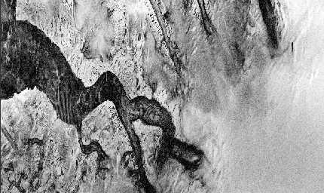
Areas with dark pixels have low coherence, and areas with lighter pixels have a higher coherence.

Next doubleclick the band prefaced with phase_ifg. Wait a few moments for the image to load and an image should appear that looks like this:
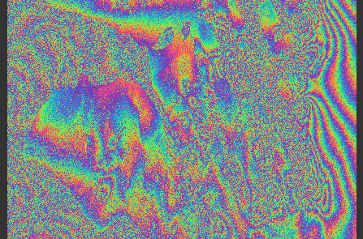

This is the interferogram. The areas with the colored bands indicate a quality signal that can be exploited.

Next step is to clean up the interferogram. Go to radar>interferometric>filtering>Goldstein Phase Filtering. The defaults are generally fine to start with. An optional coherence mask can also be applied if there is a lot of water or other low coherence areas in the image. Click run.

When complete, a new layer will be in the Product explorer. Expand the bands section again and open the new phase image. If everything ran correctly, it should look like this:
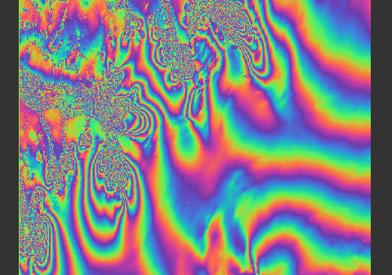
Note the cleaner fringes of color.

Next step is to determine if phase unwrapping is desired. If so, then SNAPHU will be the next step.

Navigate to Radar>Interferometric>unwrapping>Snaphu export.
Under the snaphu export tab there are several sections to set up properly.
In the top field, enter a target folder to use. It is strongly recommended to use the same folder that the rest of the images are stored in, and then create a /snaphu folder within to house the snaphu data. For simplicity, the following steps will refer to the master folder as 1, and the snaphu folder as 2.
The statistical cost mode should be adjusted for the desired signal, If the user is looking for deformation, then use DEFO. If the user is making a DEM, then use TOPO. SMOOTH can also be tried.
Click run and the snaphu export will run.

The next step is to conduct the phase unwrapping.

SNAPHU Plugin
Note: This plugin must be installed in SNAP from the plugin menu.

After running the snaphu export there are two exported file packages/folders. One will/should be within the separate SNAPHU folder (2) just created in the previous step. The other will be the primary folder(1). (These folders can be customized when setting up the graph prior to processing. It is advised to separate the Snaphu data from the rest of the image data in order to minimize the chance of confusing it later) Within the SNAPHU folder will be a Phase_ifg_VV_date1_date2.hdr snaphu file. The key parts of the file are the Phase at the beginning and the file extension of .hdr. This is the metadata file as exported and ready for phase unwrapping in SNAPHU.

Go to Radar>Interferometric>Unwrapping>Snaphu-unwrapping

Under the I/O Parameters navigate to the snaphu export folder and select the phase.hdr file.
Go to the processing parameters and make sure the write folder is the same location as the phase.hdr file used in the I/O Parameters tab. If this is not done, the process will fail.
If display execution output is checked, the status will be visible as the process runs.
Click run and wait for the tool to complete. This is likely the longest step in the process.

After SNAPHU runs, it can be closed.

Next navigate to Radar>Interferometric>Unwrapping>Snaphu-Import. Under the read phase tab, navigate to the other export folder (1). This is NOT the snaphu folder(2) if things were set up as recommended. Select the image product. Under read-unwrapped phase, go to the snaphu exports(2), and select the UnwPhase_ifg_VV_date1_date2.hdr file. In the write field, it is advised to add a _si for snaphu import. Click run and the import tool, which should only take a moment.
Again, open the new product in the product explorer, and note the new band prefixed with “unw_phase_ifg”

It should look like this:
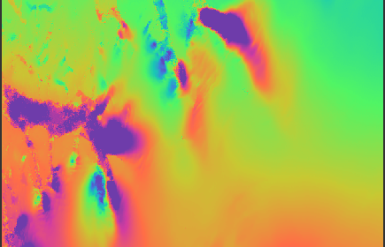

Next go to radar>interferometric>products>phase to displacement and run the newest product.
This will convert the pixels to a value representing their displacement in meters. It should look similar to the previous image, with a slightly different palette.
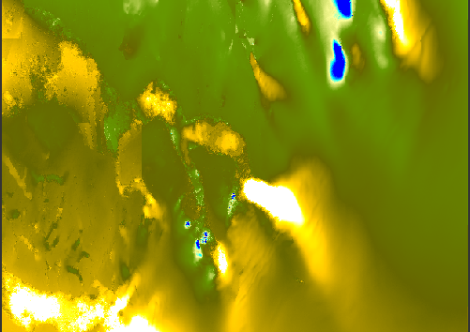

Next step is to convert the image from the slant plane to the ground plane. This will make the image suitable for loading into other platforms for visualization or additional analysis.
Go to radar>geometric>terrain correction>range doppler terrain correction
Ensure the correct source is chosen, and then under processing parameters make sure a suitable DEM is chosen. In the examples in this tutorial, the default SRTM DEM will not work as the location is too far north, so the ASTER DEM is used instead.

The resultant product should be a ground range projected, image of displacement, suitable for export or other processing.

